**1. spring-rest-handson**

**Hands on 1**

**Create a Spring Web Project using Maven** 

package com.cognizant.springlearn;

import org.springframework.boot.SpringApplication;

import org.springframework.boot.autoconfigure.SpringBootApplication;

@SpringBootApplication

public class SpringLearnApplication {

public static void main(String[] args)

{

SpringApplication.run(SpringLearnApplication.class, args);

System.out.println("Application Started Successfully!");

}

}

**Output:**

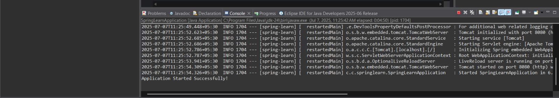

**Hands on 4**

**Spring Core – Load Country from Spring Configuration XML**

**country.java:**

package com.cognizant.springlearn;

import org.slf4j.Logger;

import org.slf4j.LoggerFactory;

public class Country {

private static final Logger LOGGER = LoggerFactory.getLogger(Country.class);

private String code;

private String name;

public Country() {

LOGGER.debug("Inside Country Constructor.");

}

public String getCode() {

LOGGER.debug("Inside getCode()");

return code;

}

public void setCode(String code) {

LOGGER.debug("Inside setCode()");

this.code = code;

}

public String getName() {

LOGGER.debug("Inside getName()");

return name;

}

public void setName(String name) {

LOGGER.debug("Inside setName()");

this.name = name;

}

@Override

public String toString() {

return "Country [code=" + code + ", name=" + name + "]";

}

}

**springLearnApplication.java:**

package com.cognizant.springlearn;

import org.slf4j.Logger;

import org.slf4j.LoggerFactory;

import org.springframework.context.ApplicationContext;

import org.springframework.context.support.ClassPathXmlApplicationContext;

public class springLearnApplication {

private static final Logger LOGGER = LoggerFactory.getLogger(springLearnApplication.class);

public static void main(String[] args) {

LOGGER.debug("START of main");

displayCountry();

LOGGER.debug("END of main");

}

public static void displayCountry() {

ApplicationContext context = new ClassPathXmlApplicationContext("country.xml");

Country country = context.getBean("country", Country.class);

LOGGER.debug("Country : {}", country.toString());

}

}

**country.xml:**

<?xml version="1.0" encoding="UTF-8"?>

<beans xmlns="http://www.springframework.org/schema/beans"

xmlns:xsi="http://www.w3.org/2001/XMLSchema-instance"

xsi:schemaLocation="

http://www.springframework.org/schema/beans

http://www.springframework.org/schema/beans/spring-beans.xsd">

<bean id="country" class="com.cognizant.springlearn.Country">

<property name="code" value="IN" />

<property name="name" value="India" />

</bean>

</beans>

**log4j.properties:**

log4j.rootLogger=DEBUG, stdout

log4j.appender.stdout=org.apache.log4j.ConsoleAppender

log4j.appender.stdout.Target=System.out

log4j.appender.stdout.layout=org.apache.log4j.PatternLayout

log4j.appender.stdout.layout.ConversionPattern=%d{HH:mm:ss} %-5p %c - %m%n

**Output:**

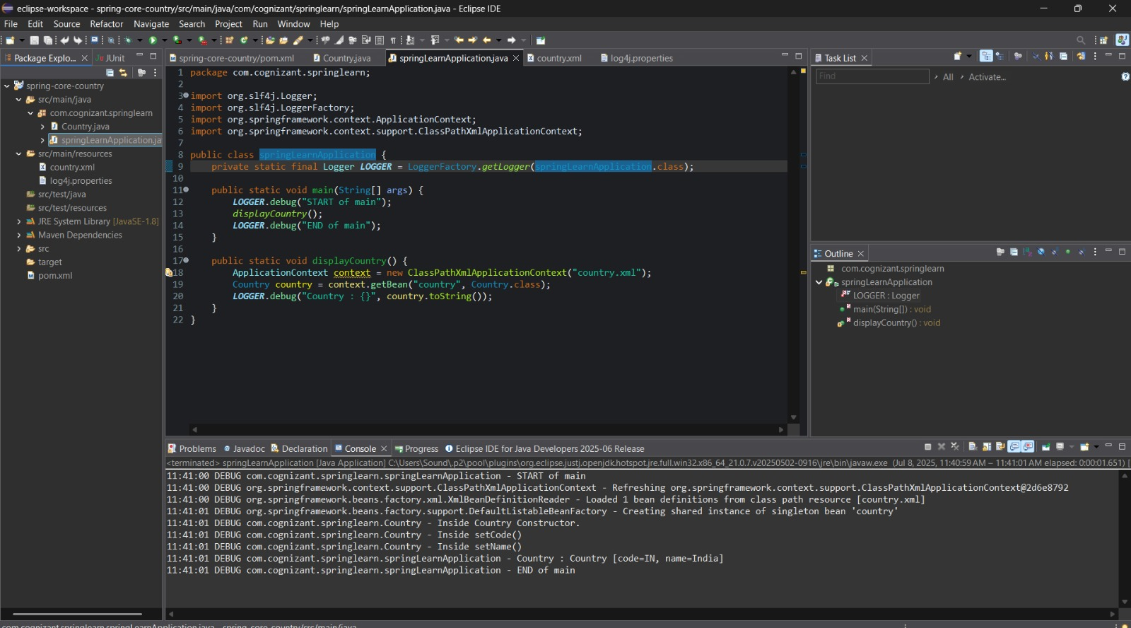

**2. spring-rest-handson**

**Hello World RESTful Web Service**

**HelloController.java:**

package com.cognizant.springlearn.controller;

import org.slf4j.Logger;

import org.slf4j.LoggerFactory;

import org.springframework.web.bind.annotation.GetMapping;

import org.springframework.web.bind.annotation.RestController;

@RestController

public class HelloController {

private static final Logger LOGGER = LoggerFactory.getLogger(HelloController.class);

@GetMapping("/hello")

public String sayHello() {

LOGGER.info("START - sayHello()");

String response = "Hello World!!";

LOGGER.info("END - sayHello()");

return response;

}

}

**SpringLearnApplication.java:**

package com.cognizant.springlearn;

import org.springframework.boot.SpringApplication;

import org.springframework.boot.autoconfigure.SpringBootApplication;

@SpringBootApplication

public class SpringLearnApplication {

public static void main(String[] args) {

SpringApplication.run(SpringLearnApplication.class, args);

}

}

**Output**:

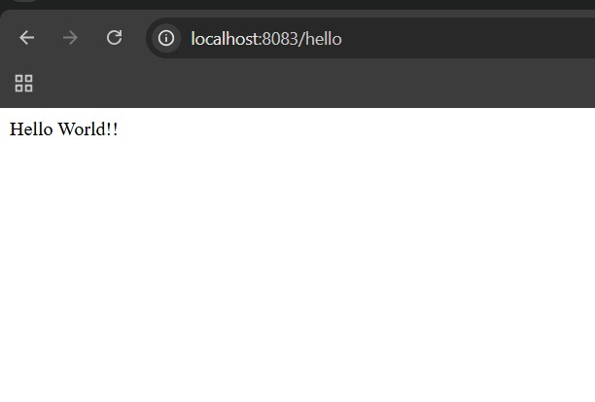

**REST - Country Web Service**

**spring.xml:**

<beans xmlns="http://www.springframework.org/schema/beans"

xmlns:xsi="http://www.w3.org/2001/XMLSchema-instance"

xsi:schemaLocation="http://www.springframework.org/schema/beans

http://www.springframework.org/schema/beans/spring-beans.xsd">

<bean id="in" class="com.cognizant.spring_learn.model.Country">

<property name="code" value="IN"/>

<property name="name" value="India"/>

</bean>

</beans>

**country.java:**

package com.cognizant.spring_learn.model;

public class Country {

private String code;

private String name;

public String getCode() {

return code;

}

public void setCode(String code) {

this.code = code;

}

public String getName() {

return name;

}

public void setName(String name) {

this.name = name;

}

}

**CountryController.java**:

package com.cognizant.spring_learn.controller;

import com.cognizant.spring_learn.model.Country;

import org.springframework.context.ApplicationContext;

import org.springframework.context.support.ClassPathXmlApplicationContext;

import org.springframework.web.bind.annotation.RequestMapping;

import org.springframework.web.bind.annotation.RestController;

@RestController

public class CountryController {

@RequestMapping("/country")

public Country getCountryIndia() {

ApplicationContext context = new ClassPathXmlApplicationContext("spring.xml");

Country country = (Country) context.getBean("in");

return country;

}

}

**SpringLearnApplication.java:**

package com.cognizant.spring_learn;

import org.springframework.boot.SpringApplication;

import org.springframework.boot.autoconfigure.SpringBootApplication;

@SpringBootApplication

public class SpringLearnApplication {

public static void main(String[] args) {

SpringApplication.run(SpringLearnApplication.class, args);

}

}

**Output:**

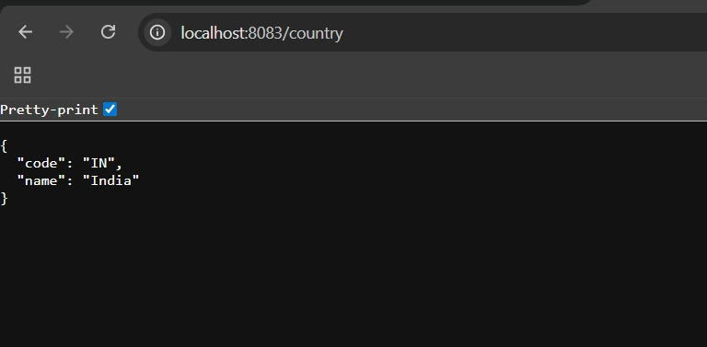

**REST - Get country based on country code**

**CountryController.java:**

package com.cognizant.spring_learn.controller;

import com.cognizant.spring_learn.model.Country;

import com.cognizant.spring_learn.service.CountryService;

import org.springframework.beans.factory.annotation.Autowired;

import org.springframework.web.bind.annotation.*;

@RestController

public class CountryController {

@Autowired

private CountryService countryService;

@GetMapping("/country/{code}")

public Country getCountry(@PathVariable String code) {

return countryService.getCountry(code);

}

}

**SpringLearnApplication.java:**

package com.cognizant.spring_learn;

import org.springframework.boot.SpringApplication;

import org.springframework.boot.autoconfigure.SpringBootApplication;

@SpringBootApplication

public class SpringLearnApplication {

public static void main(String[] args) {

SpringApplication.run(SpringLearnApplication.class, args);

}

}

**Country.java:**

package com.cognizant.spring_learn.model;

public class Country {

private String code;

private String name;

public String getCode() {

return code;

}

public void setCode(String code) {

this.code = code;

}

public String getName() {

return name;

}

public void setName(String name) {

this.name = name;

}

}

**CountryService.java:**

package com.cognizant.spring_learn.service;

import com.cognizant.spring_learn.model.Country;

import org.springframework.context.ApplicationContext;

import org.springframework.context.support.ClassPathXmlApplicationContext;

import org.springframework.stereotype.Service;

import java.util.List;

@Service

public class CountryService {

public Country getCountry(String code) {

ApplicationContext context = new ClassPathXmlApplicationContext("country.xml");

List<Country> countryList = (List<Country>) context.getBean("countryList");

return countryList.stream()

.filter(country -> country.getCode().equalsIgnoreCase(code))

.findFirst()

.orElse(null);

}

}

**country.xml :**

<beans xmlns="http://www.springframework.org/schema/beans"

xmlns:xsi="http://www.w3.org/2001/XMLSchema-instance"

xsi:schemaLocation="http://www.springframework.org/schema/beans

http://www.springframework.org/schema/beans/spring-beans.xsd">

<bean id="countryList" class="java.util.ArrayList">

<constructor-arg>

<list>

<bean class="com.cognizant.spring_learn.model.Country">

<property name="code" value="IN"/>

<property name="name" value="India"/>

</bean>

<bean class="com.cognizant.spring_learn.model.Country">

<property name="code" value="US"/>

<property name="name" value="United States"/>

</bean>

<!-- Add more countries as needed -->

</list>

</constructor-arg>

</bean>

</beans>

**Output:**

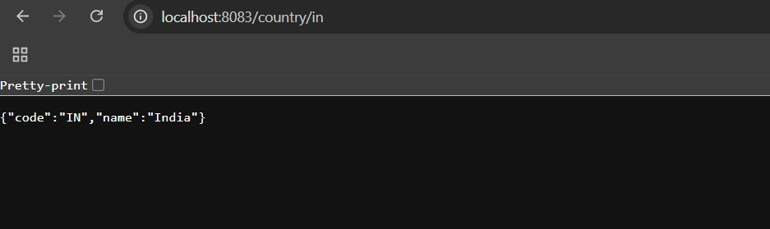

**5. JWT-handson**

**Create authentication service that returns JWT**

**DemoApplication.java:**

package com.example.demo;

import org.springframework.boot.SpringApplication;

import org.springframework.boot.autoconfigure.SpringBootApplication;

@SpringBootApplication

public class DemoApplication {

public static void main(String[] args) {

SpringApplication.run(DemoApplication.class, args);

}

}

**SecurityConfig.java:**

package com.example.demo.config;

import org.springframework.context.annotation.Bean;

import org.springframework.context.annotation.Configuration;

import org.springframework.security.config.annotation.web.builders.HttpSecurity;

import org.springframework.security.web.SecurityFilterChain;

@Configuration

public class SecurityConfig {

@Bean

public SecurityFilterChain securityFilterChain(HttpSecurity http) throws Exception {

http

.csrf().disable()

.authorizeHttpRequests(auth -> auth

.anyRequest().permitAll()

);

return http.build();

}

}

**AuthenticationController.java:**

package com.example.demo.controller;

import com.example.demo.util.JwtUtil;

import jakarta.servlet.http.HttpServletRequest;

import org.springframework.http.ResponseEntity;

import org.springframework.web.bind.annotation.*;

import java.util.Base64;

@RestController

public class AuthenticationController {

private final JwtUtil jwtUtil;

public AuthenticationController(JwtUtil jwtUtil) {

this.jwtUtil = jwtUtil;

}

@GetMapping("/authenticate")

public ResponseEntity<?> authenticate(HttpServletRequest request) {

String authHeader = request.getHeader("Authorization");

if (authHeader != null && authHeader.startsWith("Basic ")) {

String base64Credentials = authHeader.substring("Basic ".length());

byte[] decoded = Base64.getDecoder().decode(base64Credentials);

String credentials = new String(decoded);

String[] values = credentials.split(":", 2);

String username = values[0];

String password = values[1];

if ("user".equals(username) && "pwd".equals(password)) {

String token = jwtUtil.generateToken(username);

return ResponseEntity.ok().body("{\"token\":\"" + token + "\"}");

}

}

return ResponseEntity.status(401).body("Unauthorized");

}

}

**JwtUtil.java:**

package com.example.demo.util;

import io.jsonwebtoken.Jwts;

import io.jsonwebtoken.SignatureAlgorithm;

import io.jsonwebtoken.security.Keys;

import org.springframework.stereotype.Component;

import java.security.Key;

import java.util.Date;

@Component

public class JwtUtil {

private final Key key = Keys.secretKeyFor(SignatureAlgorithm.HS256);

public String generateToken(String username) {

return Jwts.builder()

.setSubject(username)

.setIssuedAt(new Date())

.setExpiration(new Date(System.currentTimeMillis() + 1000 * 60 * 10)) // 10 minutes

.signWith(key)

.compact();

}

}

**Output:**

